**Scatter Plot**

## imple Scatter Plot

Using the Sample-superstore, let's aim to find the variation of sales and profit figures as the 2 axes of the Cartesian plane distributed according to their sub-Category. To achieve this objective we follow the below steps.

* **Step-1** Drag and drop the measure **Sales** to the columns shelf.
* **Step-2** Drag and drop the measure **profit** to the rows shelf.
* **Step-3** Pull the dimension **sub-category** to the labels Shelf under Marks.

The below chart appears which shows the how profit and sales is distributed across the subcategory of products we have.

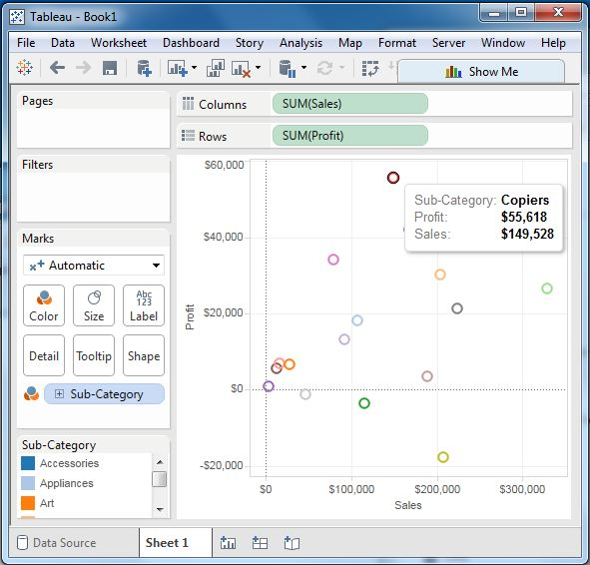

## Scatter Plot - Color Encoded

We can get the values color encoded by dragging the dimension Sub-Category to the color Shelf under the Marks card. This chart shows the scatter points with different color for each point.

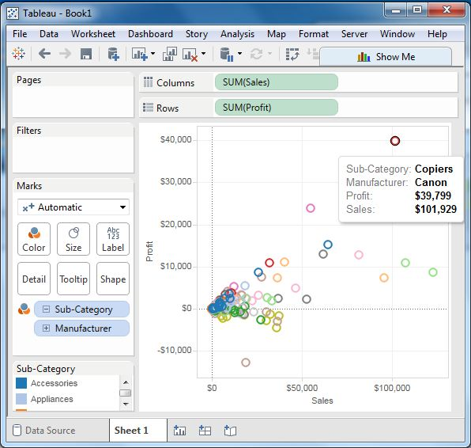

## Drill Down Scatter Plot

The same scatter plot can show different values when we choose a dimension with hierarchy. In the above example, we expand the subcategory field to show the scatter plot values for the Manufacturers.

